“When in Our Music God is Glorified”
Happy Wednesday Everyone!
Greetings from “up the mountain” at Lutheridge! This week I’m gathered with roughly 80 church musicians, pastors, and lay people from various denominations for “Music Week.” I was honored to be asked/invited to serve as chaplain for “Music Week,” and I have to be honest…I kinda hope they invite me back again sometime. What an awesome time of worship, learning and experiencing beautiful music, and time to network with other servants and gifted members of the church throughout the southeast! For those of you who enjoy music, I would highly recommend that you consider this opportunity next summer!
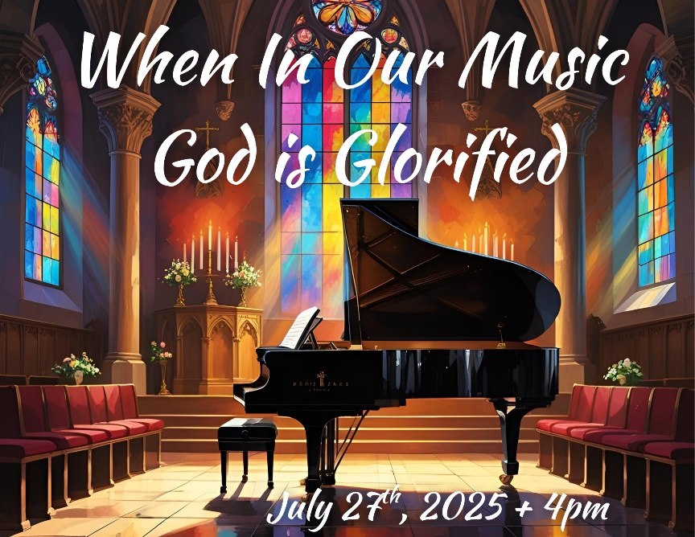
This week our “theme” is “Peace ~ Pax ~ Shalom” (those last two words are the Latin and Hebrew words for peace). We are letting music be our guide as we reflect on what peace in our minds, peace in our hearts, peace for the world, peace in our Spirit, peace with our feet, peace with our hands, and peace with our voices looks like. Sounds peaceful, doesn’t it? Sorry…that was a pun that just couldn’t be overlooked.
For roughly a month now we’ve proclaimed peace with our voices and in our song in a new way at Bethlehem. We are the blessed owners of a semi-concert Kimball Grand Piano and that piano has enriched our song in worship together. There is a hymn in the ELW titled “When in Our Music God is Glorified.” I invite you to read and reflect on two verses of that hymn:
“How oft, in make music, we have found a new dimension in the world of sound, as worship moved us to a more profound Alleluia! Let every instrument be tuned for praise; let all rejoice who have a voice to raise; and may God give us faith to sing always: Alleluia!”
The title of this hymn “When in Our Music God is Glorified” is the theme of a special upcoming event. Mark your calendars for July 27th at 4pm. We will be having a dedication concert that afternoon for our new piano. This concert will feature multiple musicians and will incorporate both congregational hymns and other music for you to simply listen to and enjoy. A reception will follow at 5pm in our Family Life Center.
Let peace be proclaimed in your voice; tell all your friends about this event and let’s “pack God’s house” for a wonderful hour of glorifying God with music and with our voices! I’m reminded especially in this season of our studying of Revelation of the song of the heavenly hosts from Revelation 5, “Blessing, honor, glory, and power belong to the one seated on the throne and to the Lamb forever and always.” We hope you can join us and look forward to singing sharing in the gift of music together on July 27th at 4pm!

Soli Deo Gloria (To God be the glory)!

Pastor Vern

