Midweek Reflection for 10/14/26
“Giving to God & Giving to Caesar”
This week’s gospel talks about everybody’s favorite topic… “giving.” Yes, I’m being facetious. But before you go running for the hills to avoid a soapbox sermon in text about giving, I want to encourage you to keep reading. “Giving” is about so much more than “giving financially.” And “giving” is about more than “giving” volunteer hours and signing up for leadership roles on ministry teams and worship responsibilities. Life itself is a participation in the act of “giving” (let me elaborate more on that statement).
From the moment we were born, when we were “given” our first breath, we entered into a “giving” relationship with all of creation. From days that gave us light and nights that gave us shade to rest; from mother’s who gave us food to grow. From seeds in soil that gave plants and trees, and those same plants, trees, and animals that gave their gifts for us (humans) to have food. For rain that gives water that sustains all life. For teachers who gave insight and imparted wisdom through teaching. For classmates and friends who give us companionship to as we grow. For healthcare workers who give healing to illness and care for our bodies. For gifts of medicine, science, literature, mathematics, history, languages, art music, athletics, and all other areas of learning that give us a greater sense of being and purpose. For vocations and institutions that give us professional responsibilities to share the gifts we have. For churches that give us insight into the questions of our faith and nurture us with the reminder of God’s presence in our lives. For partners and children who give us connection to love in new and deeper ways. The list could go on and on, and nonetheless, it can be said that life is a myriad of relationships that involve “giving.”
We will talk more about that word “giving” on Sunday, but I especially want to take a moment to specifically name a way that you can participate in the “giving” relationship of life this week:

This Sunday at 4pm, you are invited to Grace Chapel at LR for a community “World Communion Service.” A significant part of this service will be to educate and support “Kate’s Cupboard” at Lenoir-Rhyne, a food pantry created to address the concern of food insecurity among college students. Please join us for that service at 4pm if you can, and feel welcomed to bring items from the list below to contribute to Kate’s Cupboard:
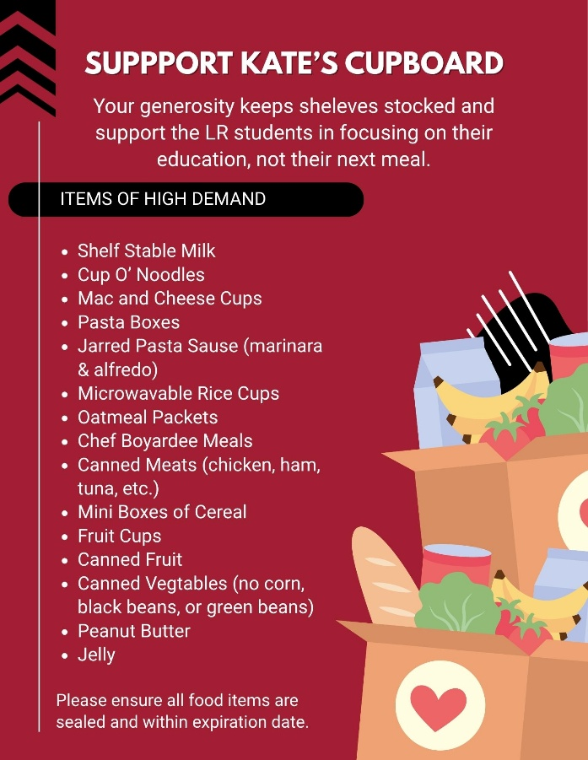
In Peace,
Pastor Vern

